**Cohen’s d**

**Cohen’d is a type of effect size between two means**

**1. Conhen’s d:** used when there are **equal group** sizes

Standarised Mean Difference (SMD)

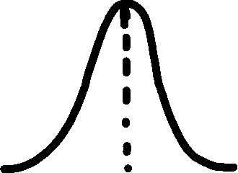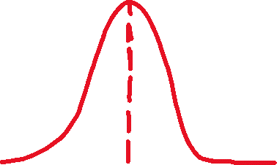

**For example:**

Cohen’s d = $\frac{1..062-0.528}{PooledSD}$ = 1.479

PooledSD = $\sqrt{\frac{({0.382}^{2}+ {0.339}^{2})}{2}}$ = 0.361

**Males**

**Mean = 0.528**

**SD (Standard Deviation) = 0.382**

**Females**

**Mean = 1.062**

**SD = 0.339**

Cohen’s d = $\frac{{Mean}_{1}- {Mean}_{2}}{PooledSD}$

PooledSD = $\sqrt{\frac{({{SD}_{1}}^{2}+ {{SD}_{2}}^{2})}{2}}$

**2. Cohen’s ds:** used when there are **unequal group** sizes



Small effect: 0.2 – 0.5

Meidum effect: 0.5 – 0.8

Large effect: d >= 0.8

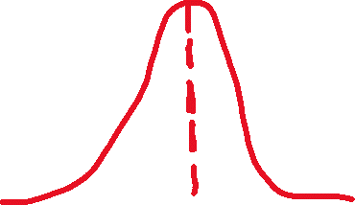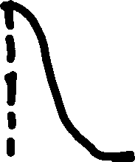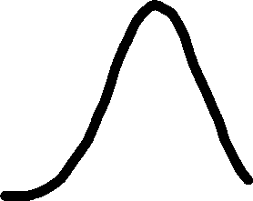

PooledSD = $\sqrt{\frac{\left(n_{1}-1\right)x {{SD}_{1}}^{2}+ {{\left(n_{2}-1\right) x SD}_{2}}^{2})}{n_{1}+ n_{2- }2}}$

= $\sqrt{\frac{\left(13-1\right) x {0.382}^{2}+\left(16-1\right)x {0.339}^{2}}{16+13 -2}}$ ≈ 0.359

Cohen’s d = $\frac{1..062-0.528}{0.359}$ ≈ 1.489

**Males**

**Mean = 0.528**

**SD (Standard Deviation) = 0.382**

**n = 13**

**Females**

**Mean = 1.062**

**SD = 0.339**

**N = 16**